Persona interviews

# Introduction

To make personas for people who could potentially play my CS awareness game, I interviewed multiple people. Three students, and one older woman, who does not have any idea about cybersecurity. The first interviewees fit in the main target group, while the last one fits in the optional target group.  
I asked the following questions:

* Do you spend a lot of time on the internet? What do you do?
* What do you know about being safe online?
* Do you feel unsafe online sometimes, in terms of getting hacked?
* Have you ever gotten a suspicious mail? If yes, what did you do about it?
* What is the best way for you to learn new things?

## Notes

Interviewee 1:

Spends a lot of time on the internet, social stuff, looking things up online.

Safety includes looking for spelling errors, not looking up illegal things, like free stuff. Also, looking at the sender of a mail, and spelling errors.

She received an SMS which asked for personal info, then clicked away and told her parents.

Best way to learn is documentation, but videos if she needs it more visual.

When small, she felt unsafe looking up a free subscription.

Interviewee 2:

Youtube, reddit, social media, checks mail every day.

Vpn, not going to suspicious websites, they can be recognized with the url. Phishing can check with email, checkmark from google, ssl certificate.

Not really had a bad scam experience.

Dozens of spam emails every day, just doesn’t open them.

Likes learning by doing, fixing your errors.

Interviewee 3:

Spends time on the internet, YT, social media, looking things up, comparing computer parts, school stuff

Vpn can be useful (it hides your ip), spam emails and websites, site was convincing even with certificate, remade website well. He removes cookies and is paranoid after.

First sold on whatsapp, he sends his bank data, he called the bank afterwards, got 5k stolen  
tip: never fill in your bank data

Learn by doing, doesn’t follow tutorials, asks others.

Interviewee 4:

Yes, youtube, bank business, sometimes check mail

She doesn’t know what is safe and what not, and often asks others for help.

She finds her bank business unsafe, and some ads that want you to click on them, things are too responsive for her, so she thinks she may accidentally click on something

It happened once, but she does not remember much. She asked somebody else to delete it.

Step by step, learning by doing, learns from mistakes.

Interviewee 5:

Doesn’t use internet often, social media, reading some things, doesn’t check mail often, though used for work

Antivirus, programs that protect, leaves most of the other

Removes suspicious mails, sees by the content (asking for money)

Mail was asking for her password, she removed it

She asks others for help with learning.

# Conclusion

## Findings

* Most people in the student age group have a good understanding of cyber security awareness already, though they may not know the specifics.
* Most people learn very much by doing, trying things out for themselves.
* Spam e-mails seem to be relatively common; everyone seems to have had them at least once.
* People usually dismiss their scam e-mails or ignore them, though usually do not report them.

## Empathy maps

Group 1: interviewees 1-3

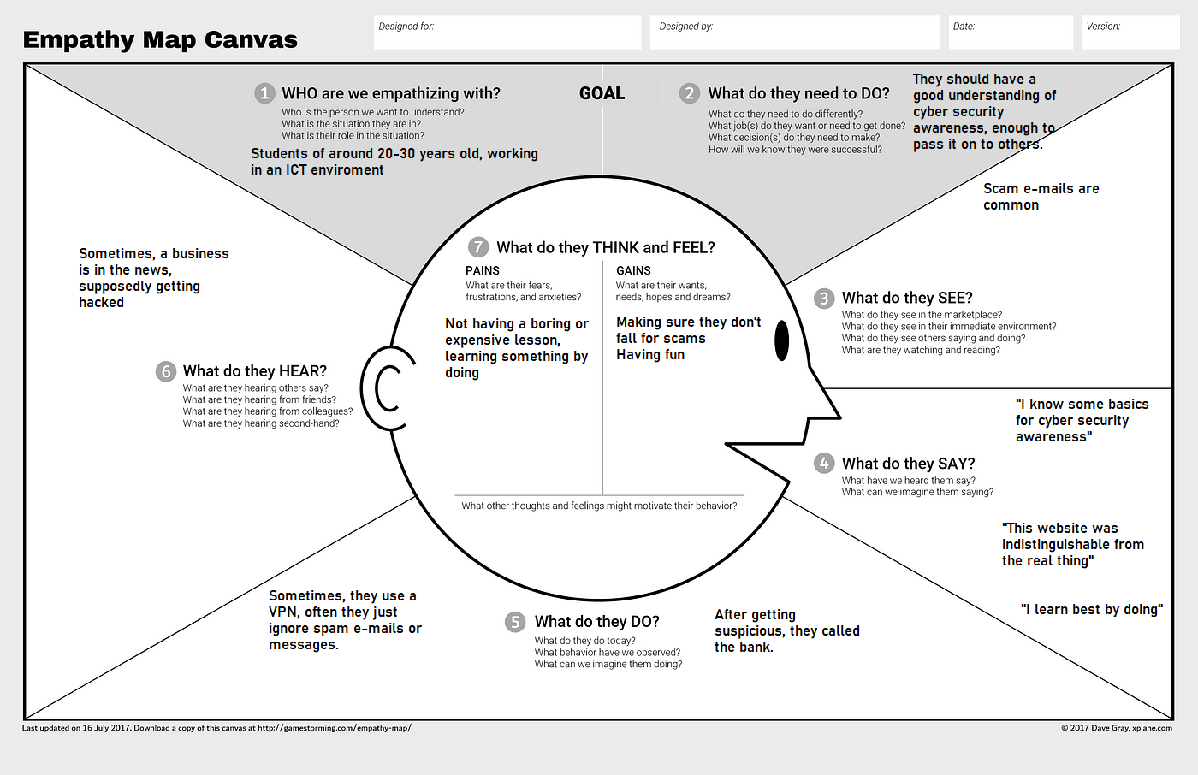

Group 2: interviewees 4 and 5